#### Travel n Explore – Amazing South Indian Trail (7Nights & 8Days)

Reference No: TnE /2752/2022

**Detailed Day Wise Itinerary**

**Travel Starts from 25th Dec 2022**

**(2N Munnar + 1N Allepphey + 1N Kovalam + 1N Kanyakumari +**

**1N Rameshwaram + 1N Madurai)**

**Flight Details – Jaipur to Kochin on 25th Dec 2022**



**Day 1 -Arrival Cochin – Munnar (110 Kms / 3 Hrs)**

On arrival at the Cochin airport/railway station, meet our representative who will be there for your warm welcome and afterwards to transfer you to your already booked hotel in Munnar Proceed to Munnar. Visit Cheeyapara and Valara water falls on the way to Munnar. Throughout the journey enjoy beautiful streams small waterfalls, Rubber, Pepper cardamom and Tea plantations and thick forests; God has blessed his own country with incomparable beauty on arrival at Munnar check in to Hotel. At leisure.

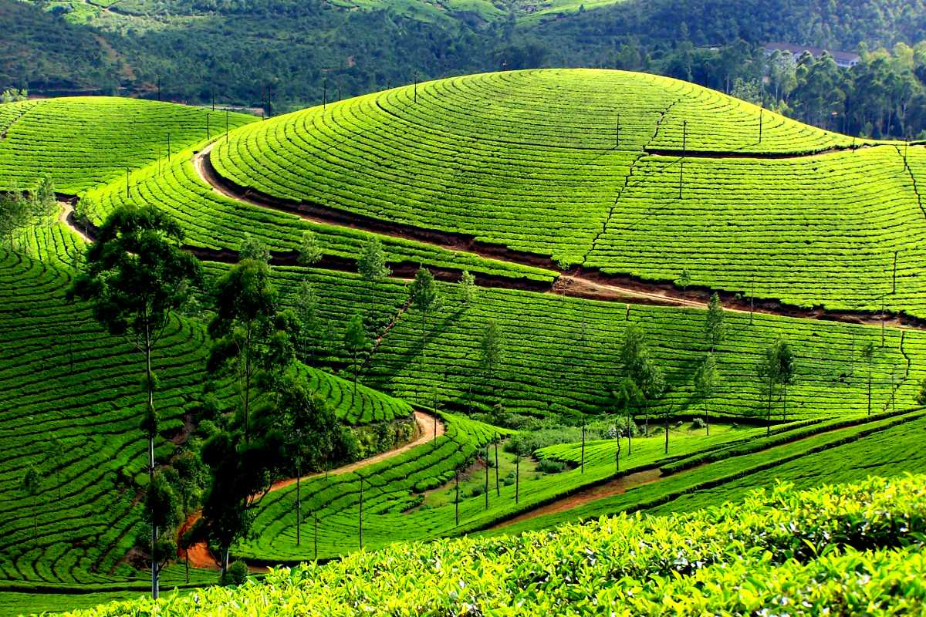

Overnight stay in Munnar.

 **Hotel**  **Transportation**  **Meals: Dinner**

**Day2 -Munnar Sightseeing**

Breakfast at the Hotel. Morning after breakfast proceed to enjoy full day sightseeing tour of Munnar. Rose Garden, Tea Garden, Photo Point, Madupetty Dam/Lake, Echo Point & Kundala Dam/Lake.

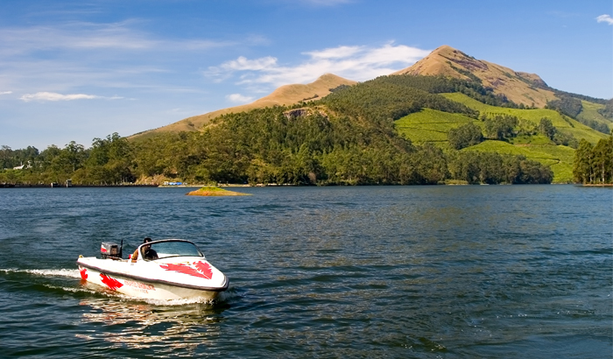

Overnight stay in Munnar.

 **Hotel**  **Transportation**  **Meals: Breakfast & Dinner**

**Day3 - Munnar to Alleppey (165 Kms / 4.5 Hrs)**

Breakfast at the Hotel, Transfers – Munnar to Alleppey

Morning after breakfast leave for Alleppey, Allappuza famous for its backwaters. Visit Alleppey beach, sunset and enjoy shopping if staying in Alleppey. Visit Alleppey Beach and Backwaters. Enjoy all the amenities of this hotel/resort for a day which includes fishing in the backwaters (depends on the hotel/resort selected)

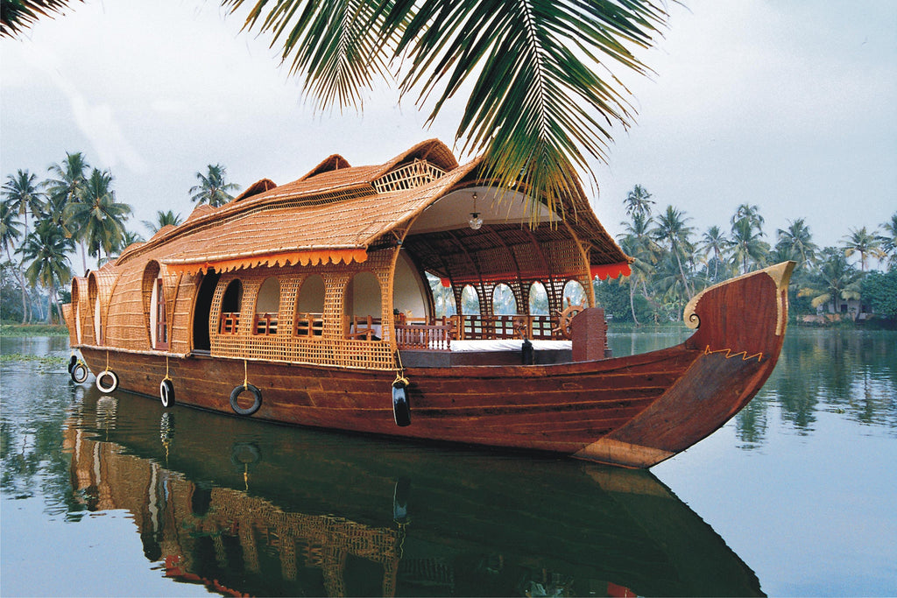

Overnight stay in Alleppey.

**Hotel**  **Transportation** **Meals: Breakfast & Dinner**

**Day4 -Alleppey to Trivendrum / Kovalam (160 Kms / 3.5 Hrs)**

Breakfast at the Hotel -Houseboat, Transfers – Alleppey to Kovalam.

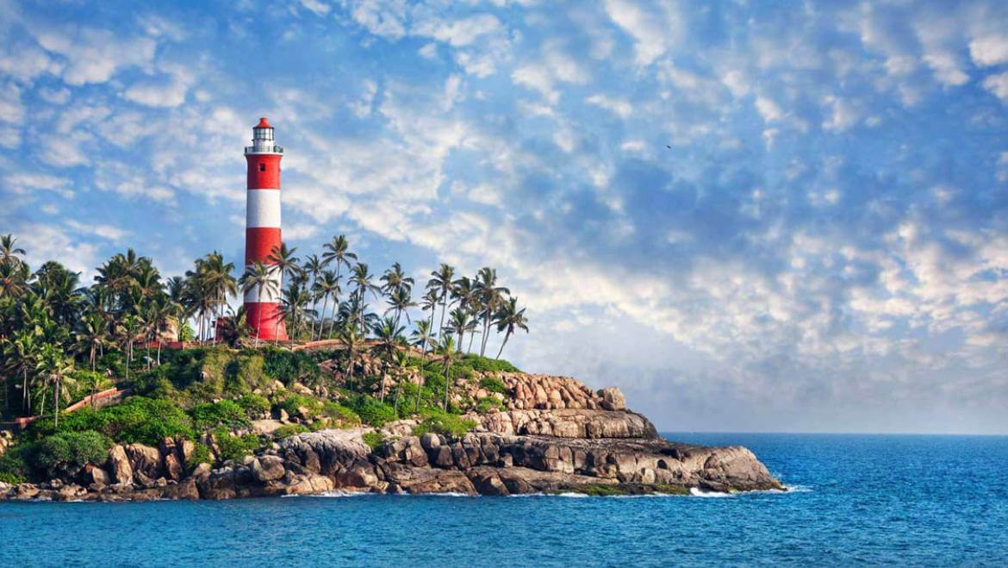

Morning after breakfast check out from the hotel Houseboat and transfer to Kovalam. Check in at Hotel. Kovalam is an evergreen and pleasant climatic beach. Kovalam is a dreamland for tourists all over the world. With high rock promontory and a calm bay of blue waters, this beach paradise creates a unique aquarelle on moonlit nights. Kovalam was brought to the public eye by the Maharaja of Travancore.

Overnight stay in Trivendrum / Kovalam.

**Hotel**  **Transportation**  **Meals: Breakfast & Dinner**

**Day5 – Trivendrum / Kovalam - Kanyakumari (90 Kms / 02 Hrs)**

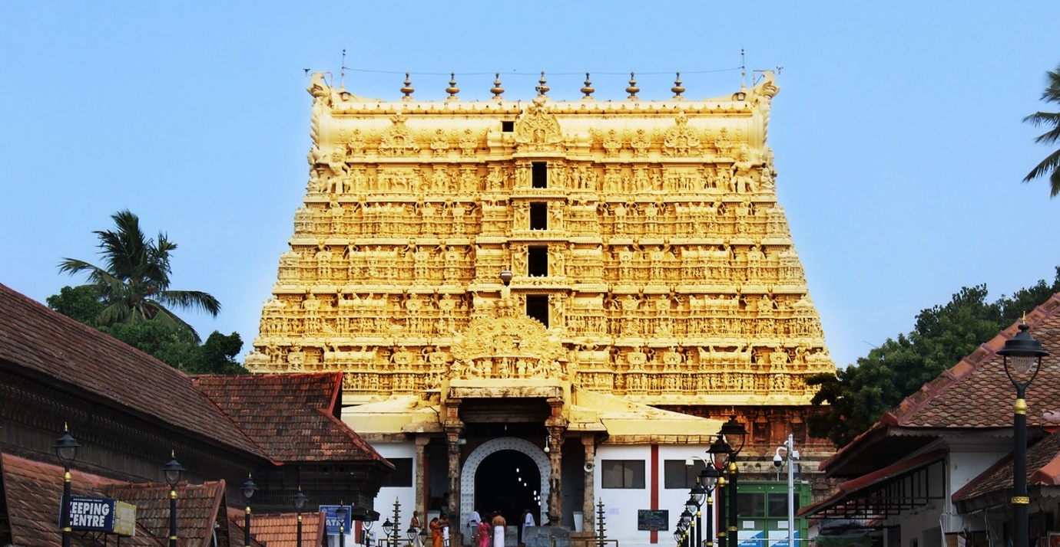

Breakfast at the Hotel, proceed for your transfer to Kanyakumari, Enroute Visit Temple of Gold Shri Padmanabham Swami Temple, check in at hotel afternoon go for Kanyakumari sightseeing. Visit Vivekananda Rock that houses a memorial dedicated to Swami Vivekananda. The Memorial is built at the convergence of the Indian Ocean, the Arabian Sea and the Bay of Bengal. Kanyakumari is a place where you can enjoy Sun rise and Sunset from the same point, something special to remember. Enjoy Sunset of Kanyakumari from the tip of India.

Overnight stay in Kanyakumari.

**Hotel**  **Transportation** **Meals: Breakfast & Dinner**

**Day6 – Kanyakumari - Rameshwaram (320 Kms / 06 Hrs)**

After breakfast check out from hotel and transfer to Rameswaram. En-route visit Thiruchendhur Murugan Temple. Arrive Rameswaram. Rameswaram is famous for Lord Rama's temple at Tamil Nadiu. Check in at Hotel. The presiding deity is the Linga Of Sri Ramanatha Swamy, which happens to be one of the twelve Jyotirlingas of India. After check in, set to Pamban Bridge - which on the Palk Strait connects Rameswaram to mainland India.

Overnight stay in Rameshwaram.

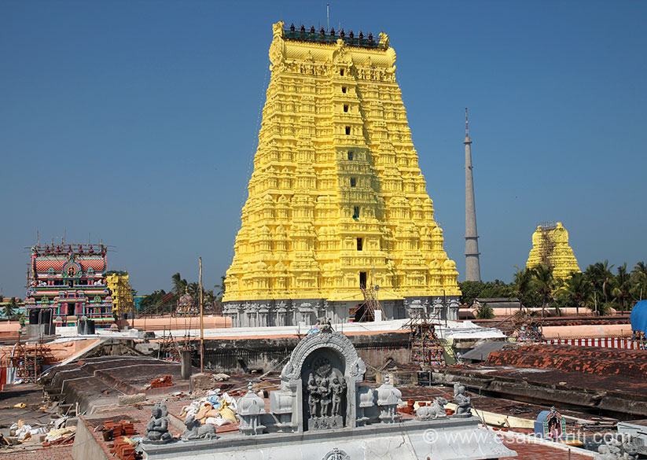

**Hotel**  **Transportation** **Meals: Breakfast & Dinner**

**Day7 – Rameshwaram – Madurai (180 Kms / 4 Hrs)**

Early Morning Darshan at Rameshwaram Temple dedicated to Lord Shiva, was constructed during the 17th century. Ramanathaswamy Temple. Agni Theertham Temple - The sacredness of the place makes it a popular bathing spot with the pilgrims. Ideally a bath at Agni Theertham precedes the visit to the Ramanatha Swamy Temple. Dhanushkodi Temple – It is believed that the bridge was built by the monkey forces of Lord Rama to access Sri Lanka. Gandamadanaparavtham - the highest point in the island. The devotees believes that lord Rama's feet was placed on the stone. After breakfast check out from hotel and proceed to Madurai. Upon arrival transfer and check in at hotel.

Overnight stay in Madurai.

**Hotel**  **Transportation** **Meals: Breakfast & Dinner**

**Day8 – Madurai – Madurai Airport Drop**

After Breakfast check out from hotel & Darshan at Minakshi Mandir, Later on transfer to Madurai Airport for your onward journey.

**Hotel**  **Transportation** **Meals: Breakfast**

**Flight Details – Madura to Jaipur on 01st  Jan 2023**



**Package Cost (Per Person)**

|  |  |  |  |
| --- | --- | --- | --- |
| **Total Persons** | **Cab** | **Rooms** | **Price** |
| 04 Adults | Innova/Similar | 2 | INR57,450 |

**Accomodation –**

|  |  |  |  |
| --- | --- | --- | --- |
| **Destination** | **Hotel / Resort** | **Total Rooms** | **Meal Plan** |
| **Munnar** | Grand Plaza (Elegance Room) | 02 | Breakfast & Dinner |
| **Alleppey** | Nohark Houseboat (02 Bed Room HB) | 02 | Breakfast, Lunch  & Dinner |
| **Trivendrum** | Apollo Dimora (Deluxe Room) | 02 | Breakfast  & Dinner |
| **Kanyakumari** | Hotel The Gopinivas Grand (Superior) | 02 | Breakfast  & Dinner |
| **Rameshwaram** | Hotel Rameswaram Grand (Superior) | 02 | Breakfast & Dinner |
| **Madurai** | Poppys Hotel Madurai (Deluxe) | 02 | Breakfast & Dinner |

**Transportation**

Innova / Similar

**Above Package Includes**

* **Return Airfare From Jaipur – Kochin & Madurai – Jaipur.**
* **7 Night stay in your preferred Hotel / Resort.**
* 02 Night Stay in Munnar with Breakfast & Dinner.
* 01 Night Stay in Alleppey Houseboat with Breakfast, Lunch & Dinner.
* 01 Night Stay in Trivendrum with Breakfast & Dinner.
* 01 Night Stay in Kanyakumari with Breakfast & Dinner.
* 01 Night Stay in Rameshwaram with Breakfast & Dinner.
* 01 Night Stay in Madurai with Breakfast & Dinner.
* Meal Plan: Breakfast & Dinner
* All Inclusion and sightseeing By Ac Vehicle as per the itinerary from 8.00 AM to 7.00 PM
* All Toll, Parking, Driver Bata & Fuel Cost

**Package does not Includes**

* GST 5% on the total package cost
* Any additional Transfers not specified in the Package Inclusions
* **Back water ride**
* Lunch & Snacks are not included
* All those which are not mentioned above
* Travel insurance
* Entry Fees To Monuments And Palaces
* Porterage At Hotels And Airports, Tips, Insurance, Laundry, Liquors, Wine, Etc
* All Items Of Personal Nature
* Any Cost Arising Due To Natural Calamities Like Landslides, Roadblocks, Etc
* Any Increase In Taxes Or Fuel Leading To An Increase In Surface Transport
* Ayurveda Charges
* Only Non Ac Rooms Are Provided In Munnar And Thekkady As They Are Hill Stations
* All kind of personal expenses such as tips, laundry, telephone bills and beverages, Camera Fees etc.
* Any other item not specified in the Package Inclusions.
* Any claim due to road blocks, curfews, accident etc.

**Payment:**

* 100 % advance.

**Refund:**

* 30 Days before full Refund
* 15 Days before 50% refund.
* 07 Days before no Refund / No Show.

For More Deals

**M:**+91 9828038888 **| e:**[contact.travelnexplore@gmail.com](mailto:contact.travelnexplore@gmail.com)**W:** [www.travelnexplore.in](http://www.travelnexplore.in/)

|  |
| --- |
| **Corporate Office :** 5th Floor, JMD Megapolis,     **Office :** B-Block, Friends Colony,  Sector-48, Sohna Road, Gurugram -122001          Vaishali Nagar, Ajmer - 305001  Contact : 9991005254                                               Contact : 9001626940 |